**Convolution Neural Network**

In deep learning, a convolutional neural network is a class of deep neural networks, most commonly applied to analysing visual imagery. It has following process which occur step by step:-

* Convolution layer
* ReLU Layer
* Pooling
* Flattening
* Fully connected

CNN gives a correct output after processing the Image through these steps.

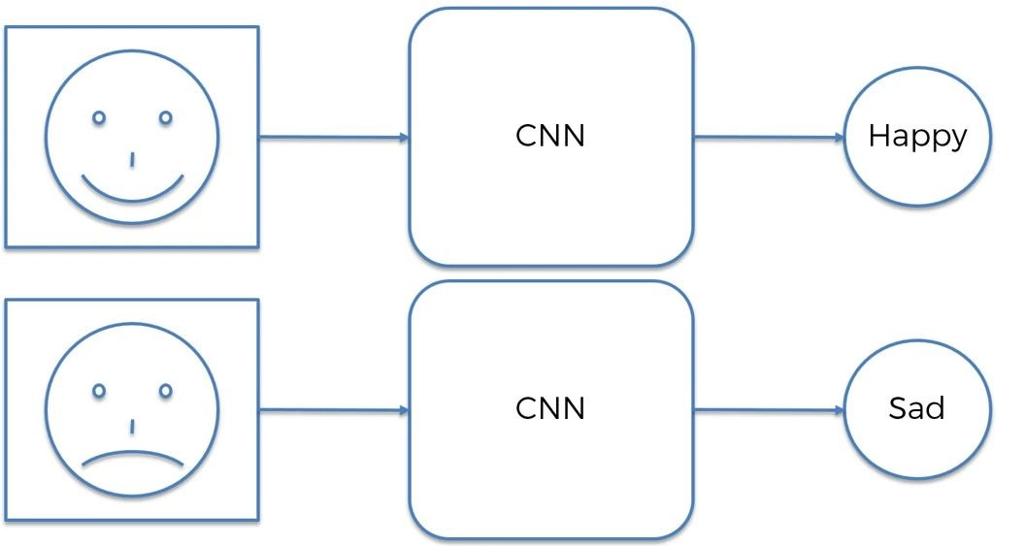

**Convolution Layer**

CNN image classifications takes an input image, process it and classify it under certain categories (Eg. Dog, Cat, Tiger, Lion). Computers sees an input image as array of pixels and it depends on the image resolution. Based on the image resolution, it will see h x w x d( h = Height, w = Width, d = Dimension ).

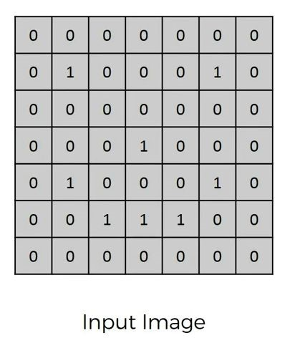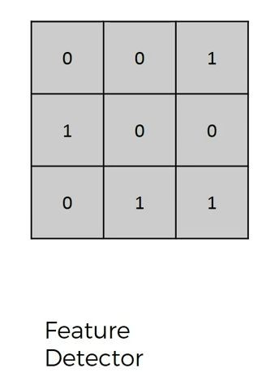

Consider a 7 x 7 whose image pixel values are 0, 1 and filter matrix 3 x 3 as shown in above. Then the convolution of 7 x 7 image matrix multiplies with 3 x 3 filter matrix which is called **“Feature Map”** as output shown in below.

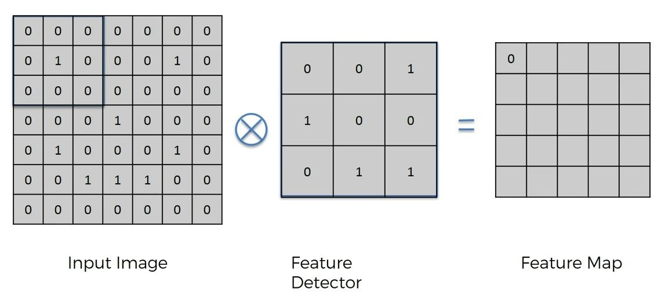

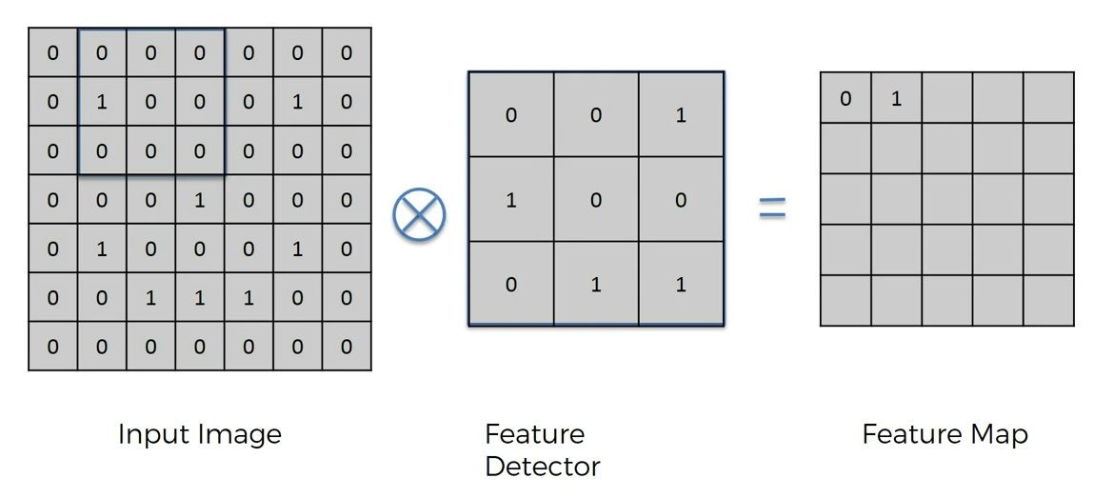

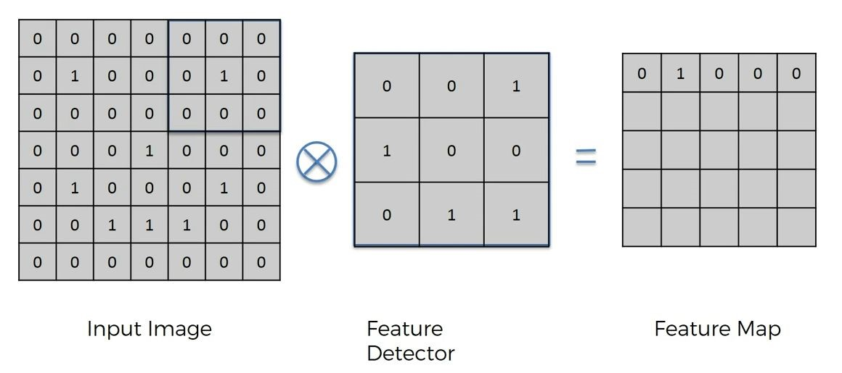

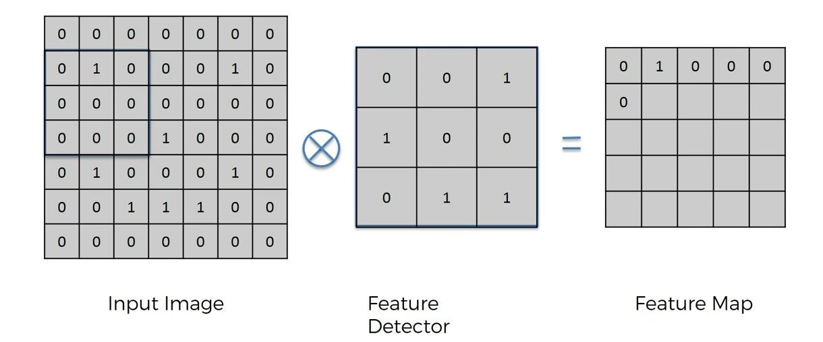

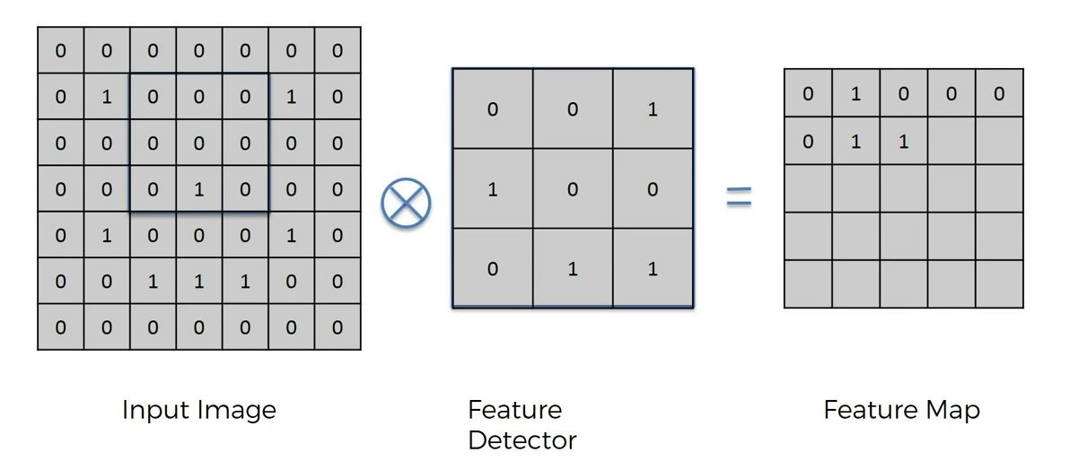

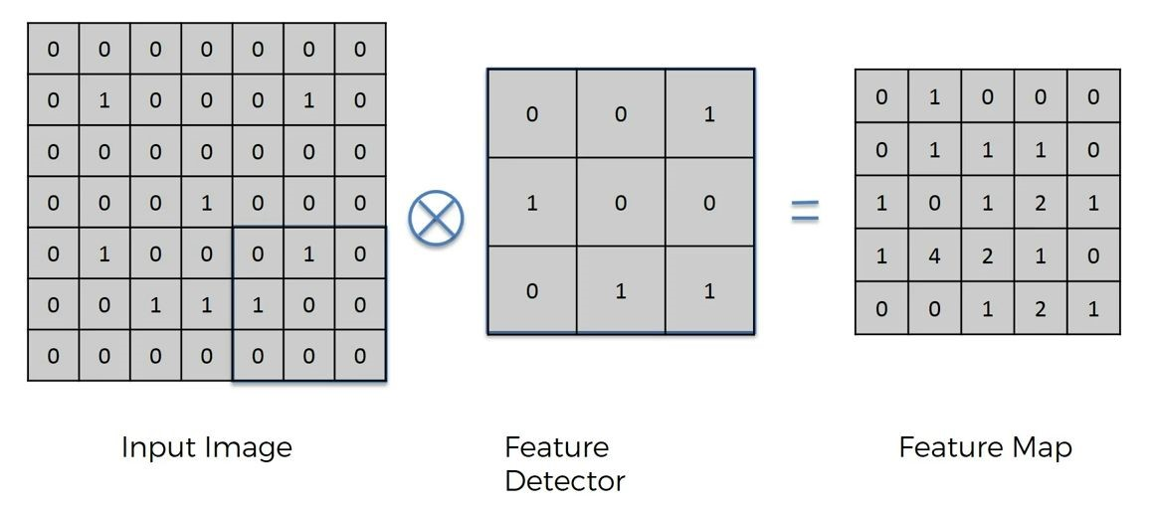

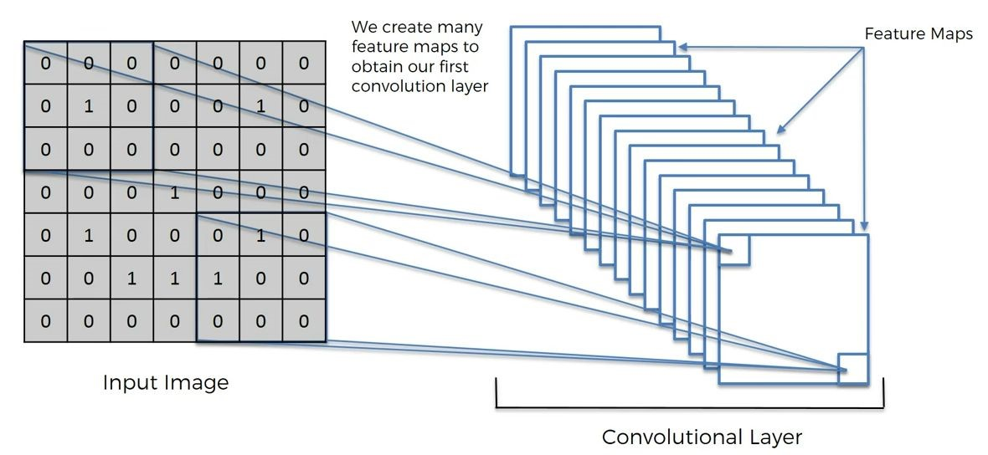

Convolution of an image with different filters can perform operations such as edge detection, blur and sharpen by applying filters. The below example shows various convolution image after applying different types of filters

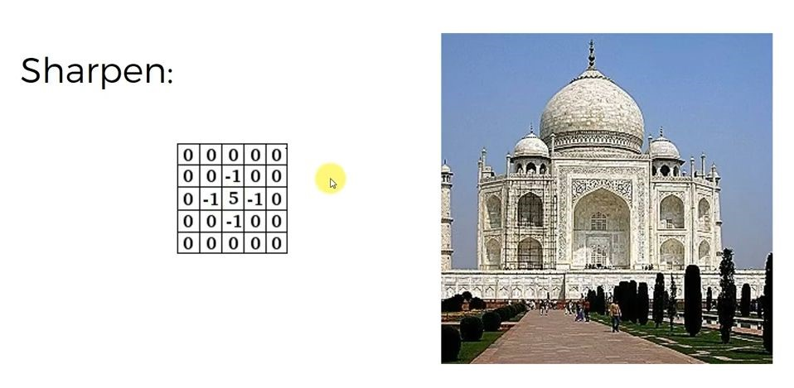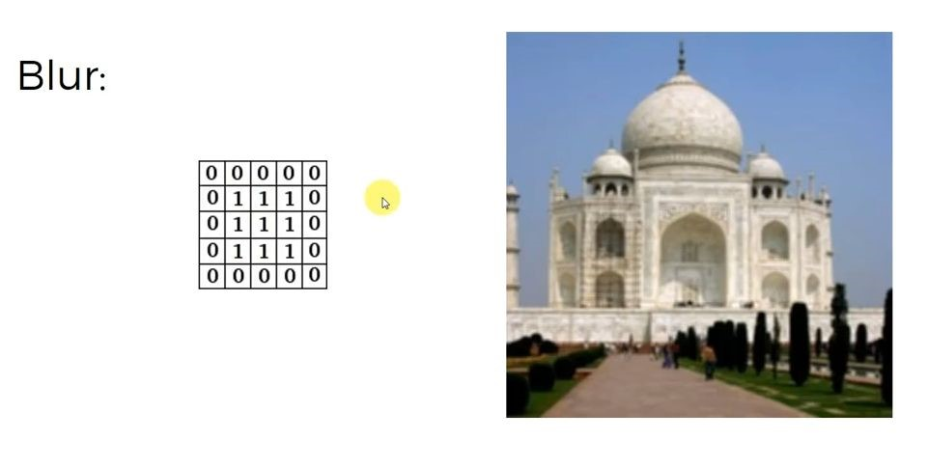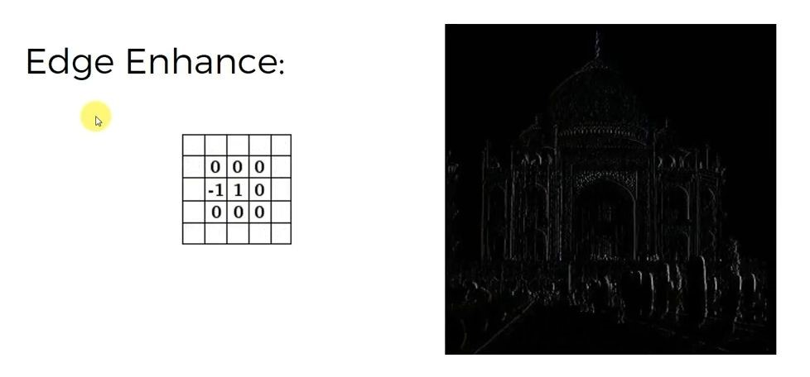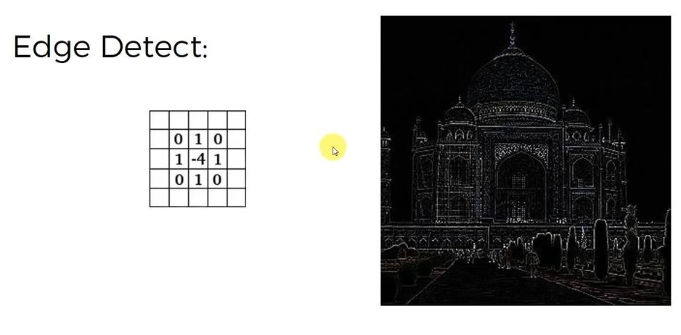

**ReLU Layer**

ReLU stands for Rectified Linear Unit for a non-linear operation. The output is **ƒ(x) = max(0,x).**

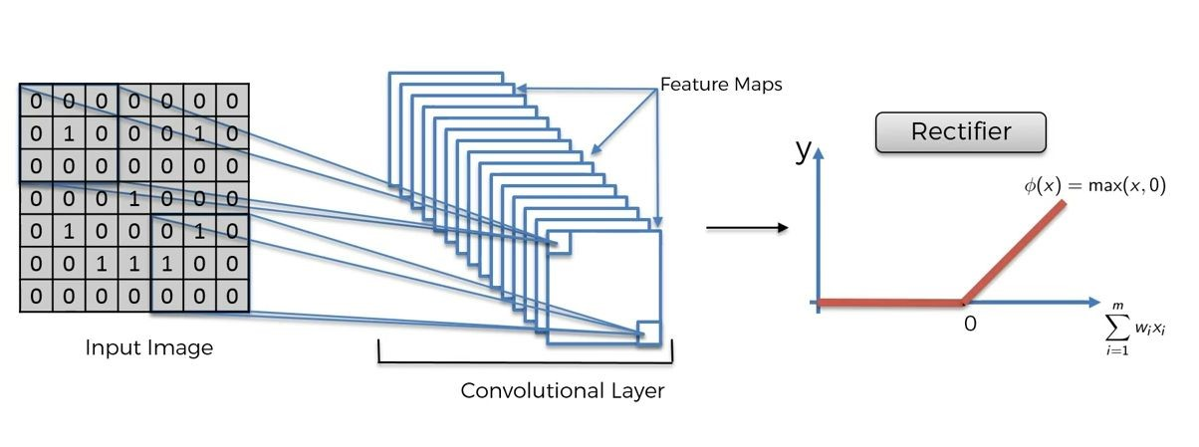

ReLU’s purpose is to introduce non-linearity in our Convolution Layer. Since, the real world data would want our Convolution Layer to learn would be non-negative linear values. Most of the data scientists use ReLU since performance wise ReLU is better than the other two.

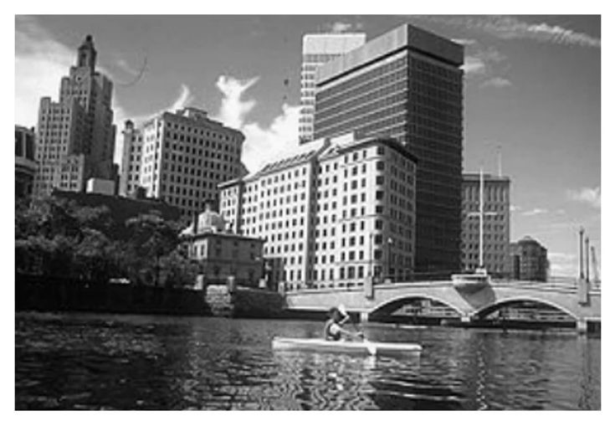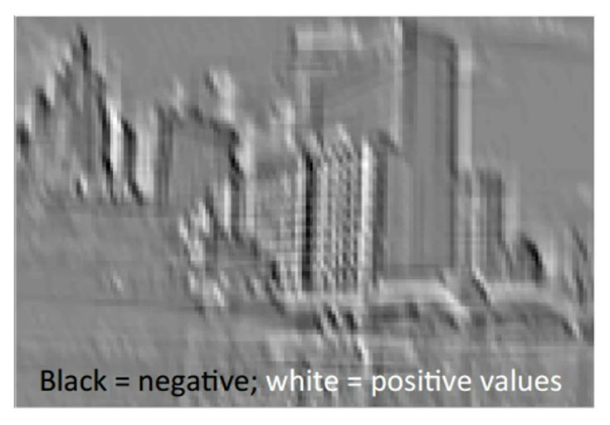

Normal Image Convolution layer

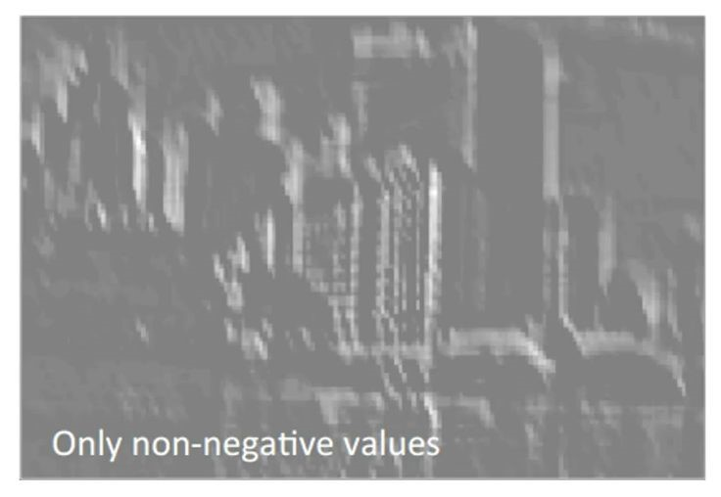

ReLU layer

**Max** **Pooling**

Pooling layers section would reduce the number of parameters when the images are too large. Max pooling takes the largest element from the rectified feature map. Taking the largest element could also take the average pooling. Sum of all elements in the feature map call as sum pooling.

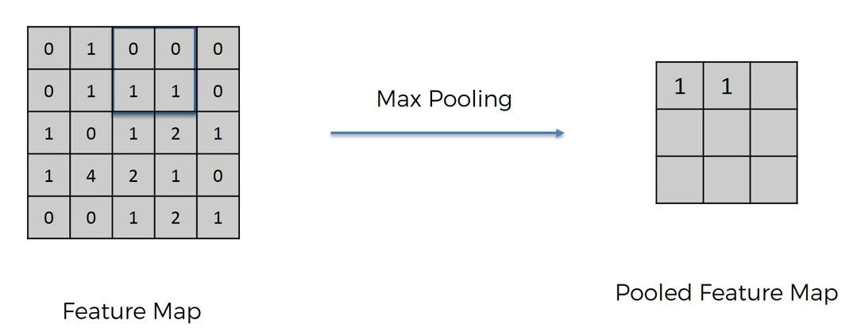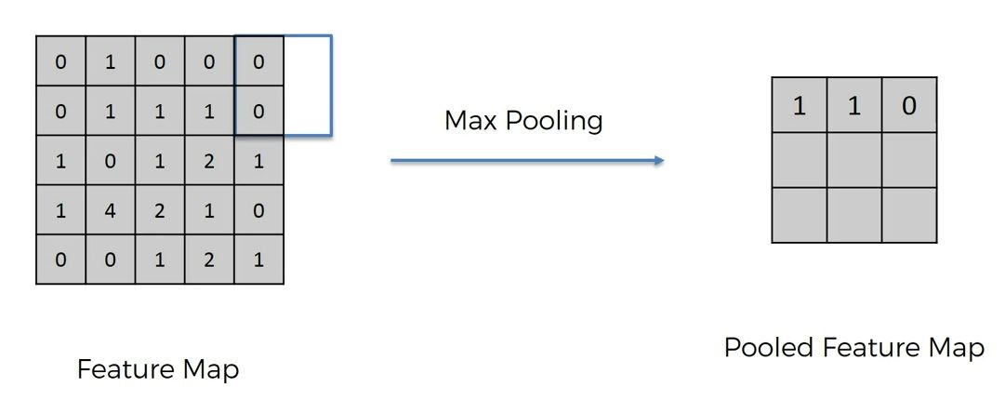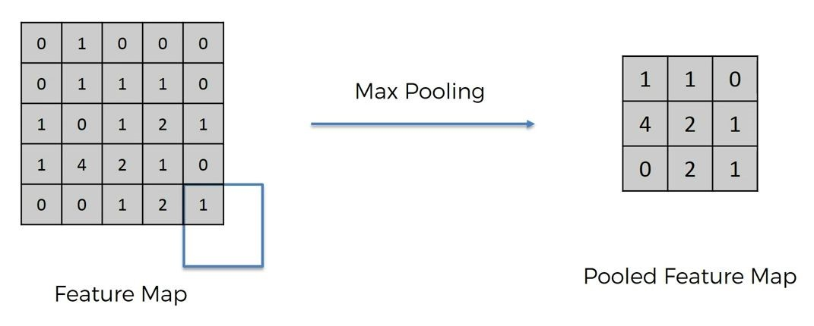

**Flattening**

**Flattening** is converting the data into a 1-dimensional array for inputting it to the next layer. The last stage of a convolutional neural network (CNN) is a classifier. It is called a dense layer, which is just an artificial neural network (ANN) classifier.

And an ANN classifier needs individual features, just like any other classifier. This means it needs a feature vector.

Therefore, you need to convert the output of the convolutional part of the CNN into a 1D feature vector, to be used by the ANN part of it. This operation is called flattening. It gets the output of the convolutional layers, flattens all its structure to create a single long feature vector to be used by the dense layer for the final classification.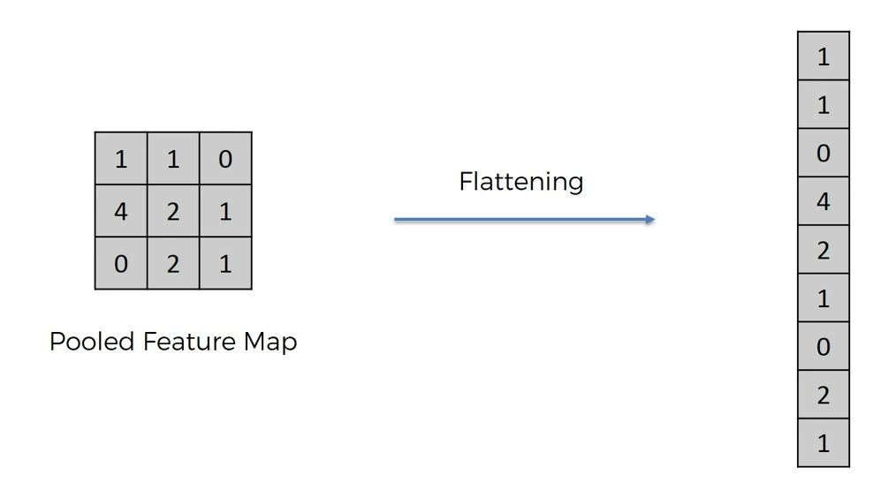

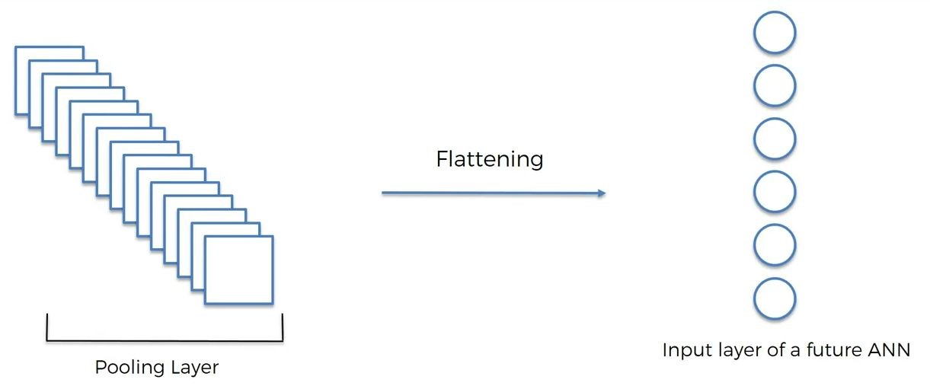

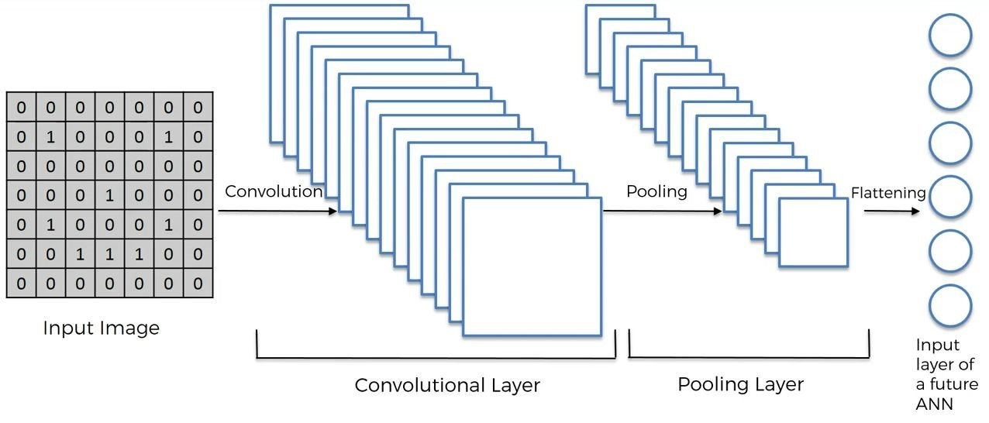 conv. 2 p2

Input image

Pooling layer 1

Convolution Layer 1

Input layer

of

future ANN

Adding multiple convolutional layers and pooling layers, the image will be processed for feature extraction. As the layers go deeper and deeper, the features that the model deals with become more complex. For example, at the early stage of Convlayer, it looks up for oriented line patterns and then finds some simple figures. At the deep stage, it can catch the specific forms of objects and finally able to detect the object of an input image.

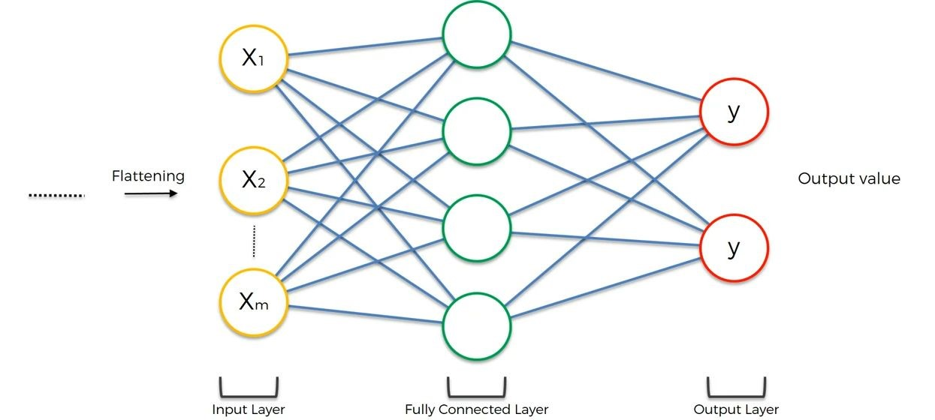

This is an artificial neural network in cnn. An **input layer**which is the data we provide to the ANN**.**We have the **hidden layers**, which is where the magic happens. Lastly, we have the **output layer**, which is where the finished computations of the network are placed for us to use.

**Fully Connected Layer**

The layer we call as FC layer, we flattened our matrix into vector and feed it into a fully connected layer like a neural network.

In our ANNs we have these units of calculation called **neurons**. These artificial neurons are connected by **synapses** which are really just weighted values. What this means is that given a number, a neuron will perform some sort of calculation and then the result of this calculation will be multiplied by a weight as it “travels.”

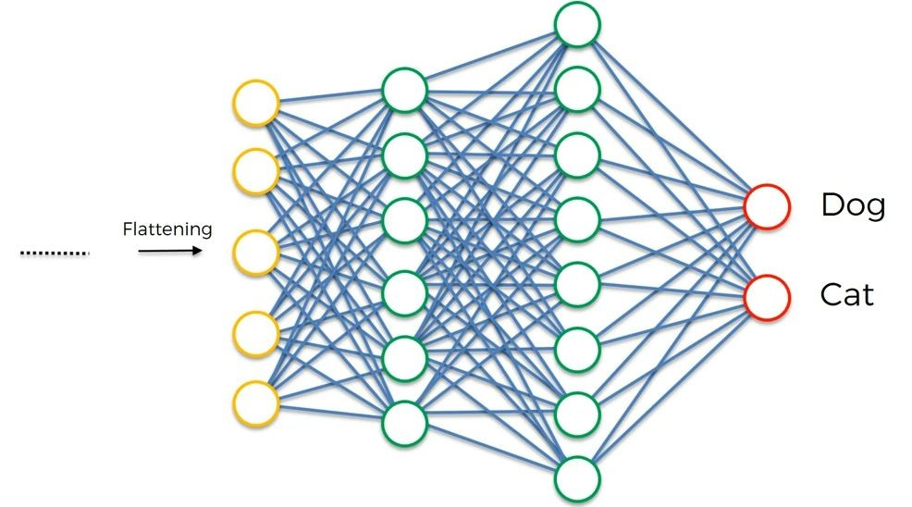

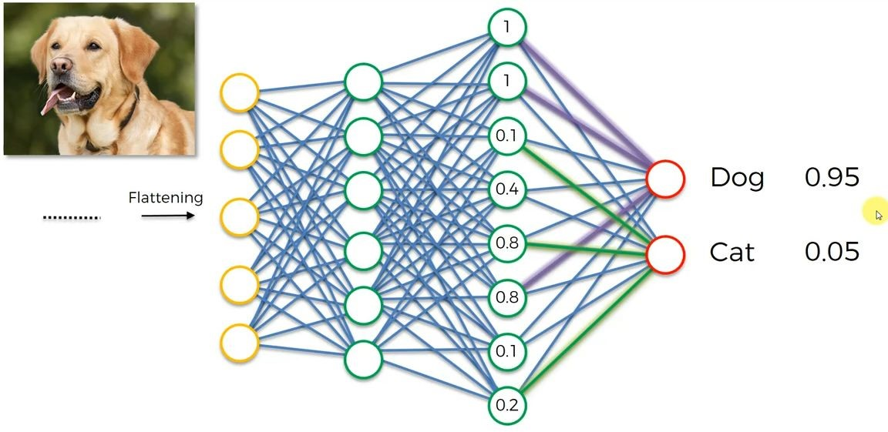

Female 2.5%e

Male 9.5%e